The Americans with Disabilities Act

Your Rights. Your Access. Your Power.
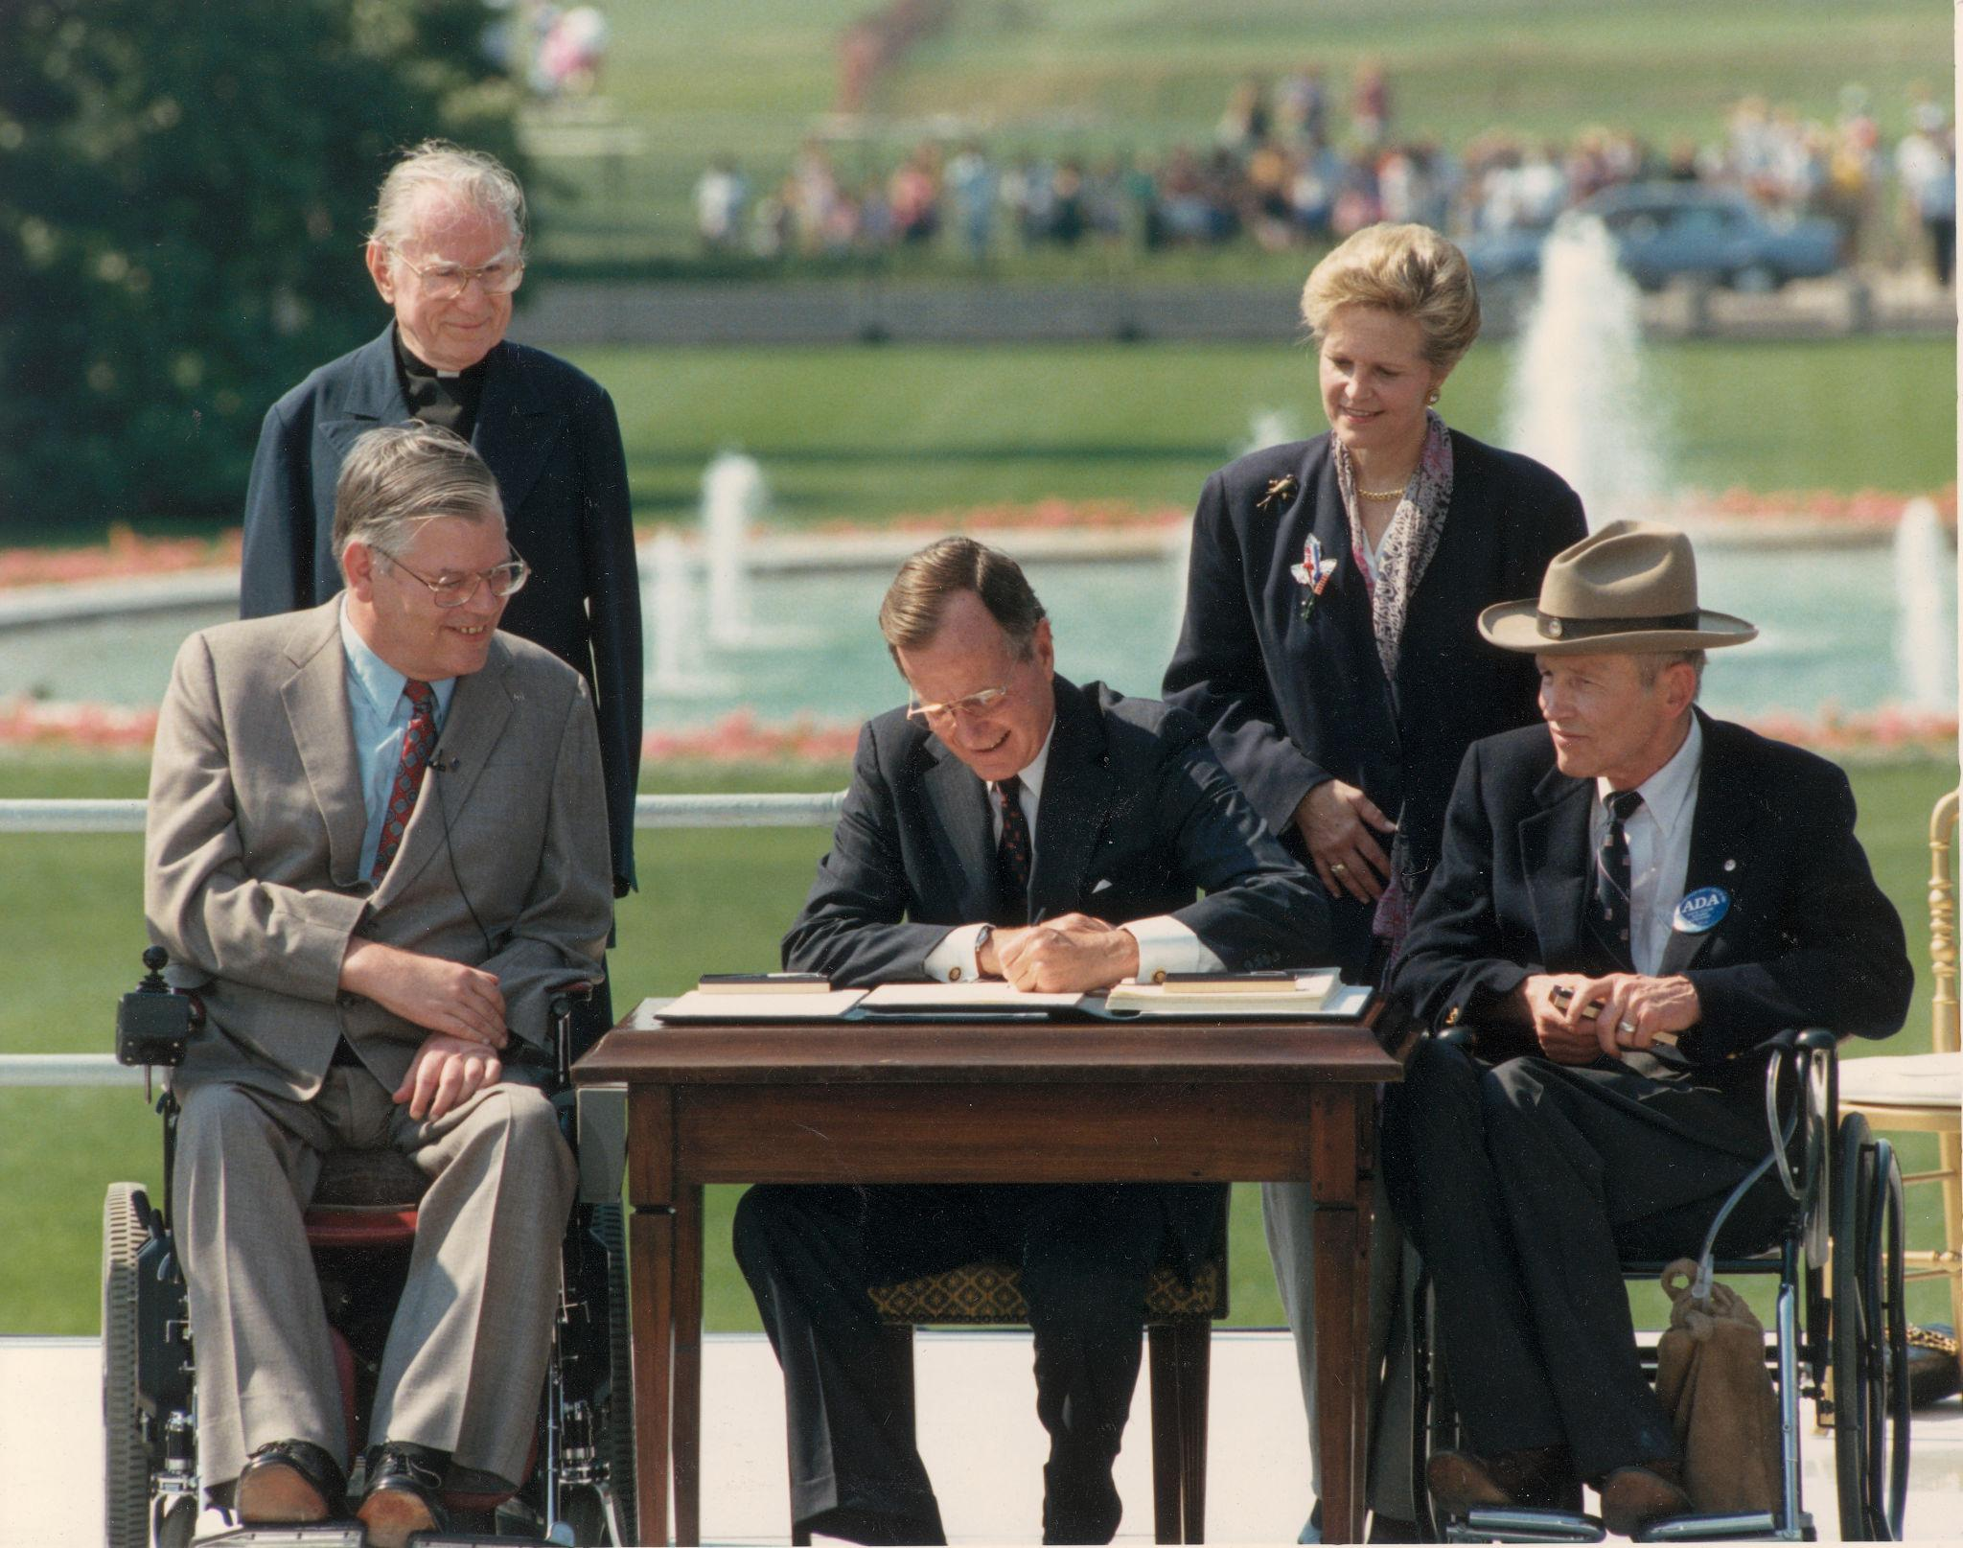
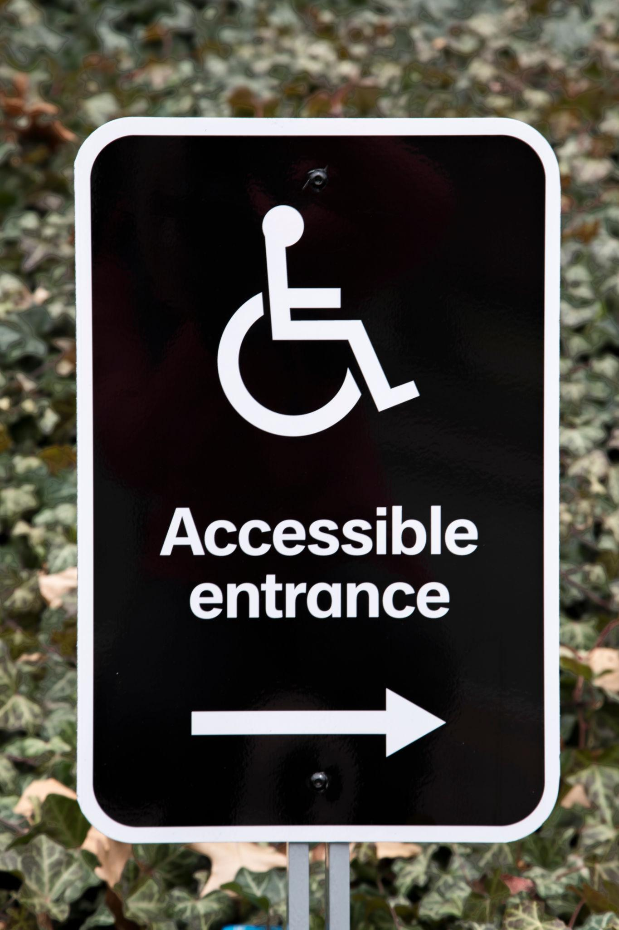



What Is the ADA?
The Americans with Disabilities Act is a federal civil rights law passed in 1990.
It prohibits discrimination against people with disabilities in:
- Employment
- Public services
- Public accommodations
- Transportation
- Telecommunications
In plain English: if you have a disability, you have the same right to participate in society as anyone else. Full stop.

Who Is Protected?
You are protected if you:
- Have a physical or mental impairment that substantially limits one or more major life activities
- Have a record of such an impairment
- Are regarded as having such an impairment
“Major life activities” includes things like walking, seeing, hearing, learning, working, concentrating, and major bodily functions.
The ADA does not require you to be helpless. It requires you to be human.

The Five Titles of the ADA
Because lawmakers love structure.

Title I: Employment
Applies to employers with 15 or more employees.
Employers cannot:
- Refuse to hire you because of your disability
- Fire you because of your disability
- Deny reasonable accommodations
You are entitled to a reasonable accommodation unless it creates an undue hardship for the employer.
Examples:
- Modified schedule
- Remote work
- Assistive technology
- Physical workspace modifications

Title II: State and Local Government
Applies to public entities.
Government programs must be accessible. That includes:
- Public schools
- Courts
- Licensing agencies
- Workforce programs
If a state agency offers services, they cannot quietly exclude you and call it policy.

Title III: Public Accommodations
Applies to private businesses open to the public.
Examples:
- Restaurants
- Retail stores
- Hotels
- Dispensaries
- Professional offices
If the public can walk in, accessibility is not optional.

Title IV: Telecommunications
Requires telephone and internet companies to provide relay services for people with hearing or speech disabilities.

Title V: Miscellaneous Protections
Includes anti retaliation protections.
If you assert your rights, you cannot legally be punished for it.
That one matters.

What Is a Reasonable Accommodation?
A reasonable accommodation is a modification or adjustment that allows a person with a disability to:
- Apply for a job
- Perform essential job functions
- Access a service
- Participate in a program
The key phrase is essential functions. You must be qualified for the role or service. The ADA does not require an employer to eliminate core job duties.
It does require creativity and fairness.

What Is “Undue Hardship”?
An employer or entity can deny an accommodation if it would cause significant difficulty or expense.
Not inconvenience. Not mild discomfort. Not “we’ve never done that before.”
Significant difficulty or expense.
There is a difference.

ADA and Section 504
The ADA works alongside Section 504 of the Rehabilitation Act.
Section 504 applies to programs receiving federal funding.
That means if a program takes federal dollars, disability discrimination is prohibited. Period.
This includes many vocational rehabilitation programs, colleges, and nonprofits.

What the ADA Does Not Do
Let’s kill the myths.
The ADA does not:
- Guarantee employment
- Require employers to lower standards
- Protect illegal activity
- Force businesses to go bankrupt
It guarantees equal opportunity. Not special treatment. Equal treatment.

If You Think Your Rights Were Violated
You can:
- File an internal complaint
- File with the EEOC for employment discrimination
- File with the Department of Justice for public accommodation issues
- Request mediation
- Consult an attorney
Documentation matters. Dates matter. Written communication matters.
Always create a paper trail.

Why This Matters
The ADA is not charity law.
It is civil rights law.
It exists because exclusion was normalized.
It exists because access was denied.
It exists because people fought.
And it only works when people use it.

