Retaliation Protection: The Quiet Engine Behind Civil Rights Enforcement
Retaliation law is not an accessory to civil rights. It is the enforcement mechanism.
Without it, anti-discrimination statutes collapse under pressure. Employees, students, and program participants would simply stay silent.
Federal law recognizes this reality. That is why retaliation protections are written directly into the statutes themselves.

The Statutory Backbone

Americans with Disabilities Act

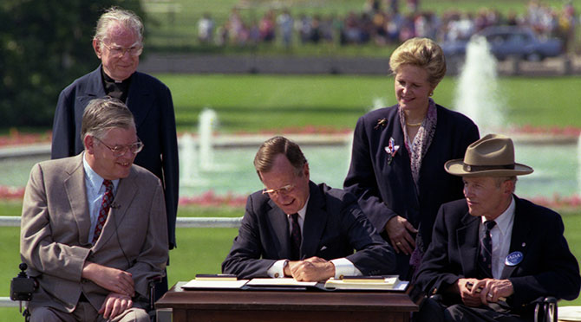

The ADA does more than prohibit discrimination. It explicitly bars retaliation and coercion against individuals who assert their rights.
Protected activity includes:
• Requesting reasonable accommodations
• Filing internal or external complaints
• Participating in investigations
• Supporting another person’s discrimination claim
The standard is straightforward. If an employer or public entity takes action that would deter a reasonable person from asserting rights, it may constitute retaliation.

Rehabilitation Act of 1973 Section 504
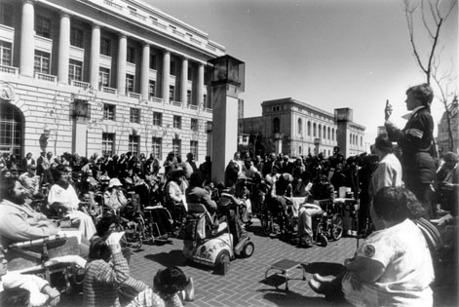

Section 504 applies to entities receiving federal financial assistance, including schools, healthcare institutions, and state agencies.
The statute prohibits both discrimination and retaliation.
In practical terms, a federally funded agency cannot reduce services, threaten termination, or materially alter participation because an individual filed a complaint or challenged a decision.
Timing and documentation often determine how these cases unfold.

The Supreme Court Standard

Burlington Northern & Santa Fe Railway Co. v. White

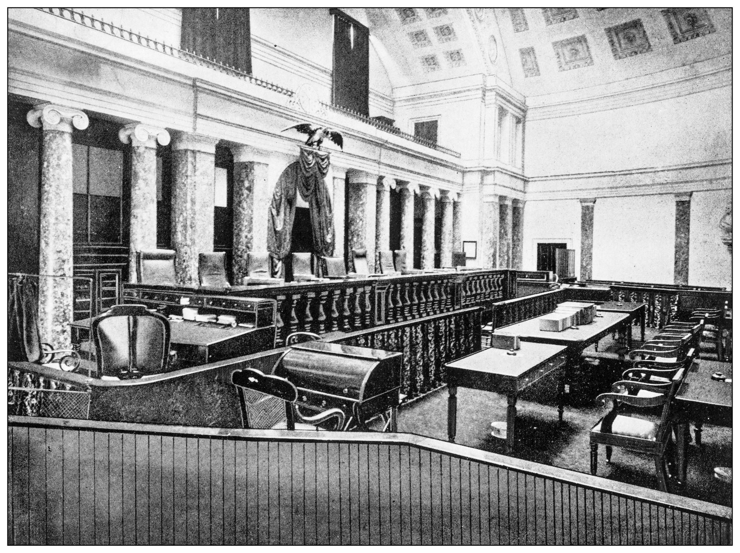
In 2006, the Supreme Court clarified the retaliation standard.
An action is unlawful if it would dissuade a reasonable person from making or supporting a discrimination complaint.
The Court rejected the notion that only formal employment actions such as termination qualify. Reassignments, heightened scrutiny, or other materially adverse actions can meet the threshold.
The test is functional. Would the action chill protected activity?

The Litigation Framework

McDonnell Douglas Corp. v. Green
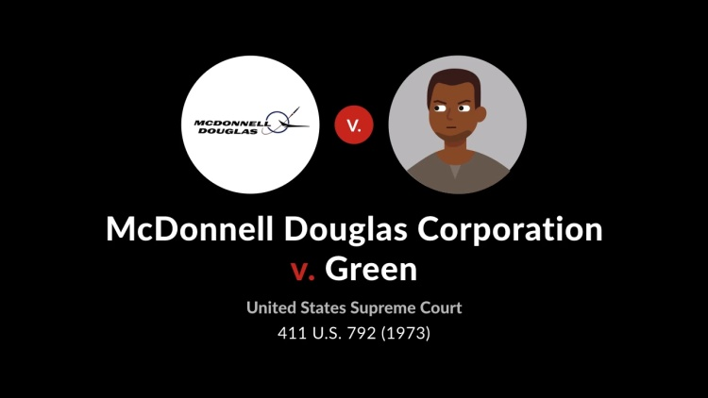
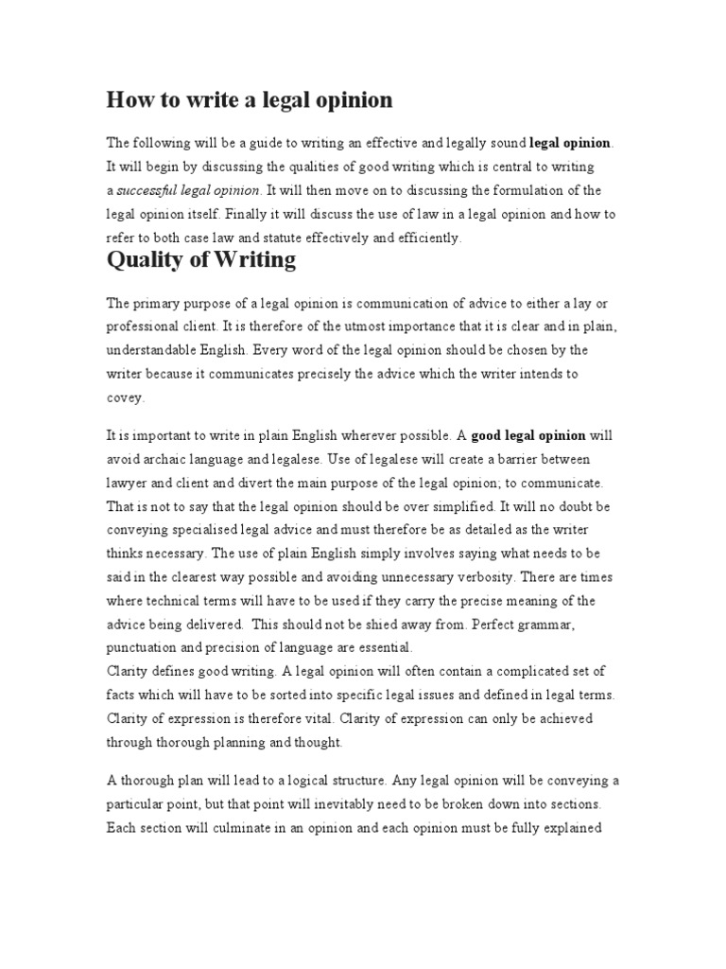

Courts apply a burden-shifting framework:
- The claimant establishes protected activity and adverse action
- The employer or agency offers a legitimate, non-retaliatory reason
- The claimant demonstrates that the explanation is pretext
Proximity in time between complaint and adverse action often becomes a focal point.
Retaliation claims frequently turn on documentation rather than rhetoric.

What Qualifies as Retaliation?
Examples include:
• Termination or demotion
• Threatened loss of services
• Negative performance reviews following a complaint
• Increased monitoring
• Exclusion from projects or meetings
• Hostile treatment linked to protected activity
The law does not require dramatic circumstances. It requires causation.

Why It Matters
Retaliation protections preserve the integrity of the civil rights framework.
Without them, the cost of speaking up would be too high for most individuals. Enforcement agencies rely on complaints. Courts rely on litigants. Rights depend on participation.
Retaliation law ensures that participation does not carry punishment.
It is less visible than discrimination law. It is arguably more consequential.
When institutions understand that protected activity cannot be penalized, compliance becomes rational.
When they do not, litigation follows.
And litigation, unlike silence, leaves a record.

