What Are Workplace Accommodations?
A workplace accommodation is a reasonable adjustment that allows a qualified person with a disability to perform essential job functions.
That’s it. Not special treatment. Not favoritism. Not charity. Access.
Under the Americans with Disabilities Act and Section 504 of the Rehabilitation Act of 1973, employers with 15 or more employees must provide reasonable accommodations unless doing so causes undue hardship.
Translation: If it’s doable and not financially catastrophic, they’re supposed to do it.

What Counts as a Disability?
A physical or mental impairment that substantially limits one or more major life activities.
Major life activities include:
- Walking
- Seeing
- Hearing
- Concentrating
- Working
- Communicating
- Thinking
- Regulating emotions
And yes, that includes many invisible disabilities. The law does not require you to “look disabled.”

What Is a Reasonable Accommodation?
A change that enables equal access to employment. Examples:

🪑 Physical Adjustments




- Ergonomic chairs
- Adjustable desks
- Modified workstations
- Accessible entrances

⏰ Schedule Modifications


- Flexible hours
- Remote work
- Modified shifts
- Part time arrangements

🧠 Cognitive and Mental Health Supports
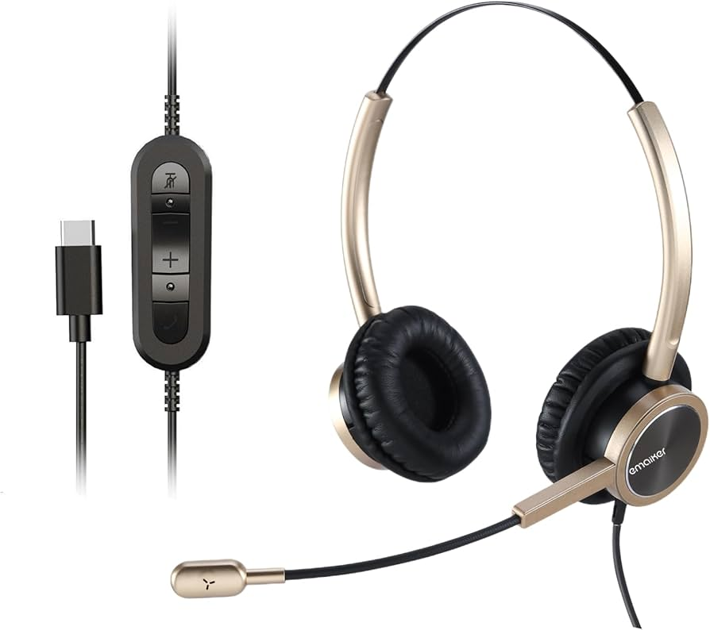

- Noise reducing headphones
- Written instructions instead of verbal only
- Task lists or checklists
- Quiet workspace

📚 Policy Adjustments
- Additional unpaid leave
- Reassignment to a vacant position
- Modified workplace policies
- Adjusted performance measurement methods
Notice what’s not on the list: “Lower standards.”
You still have to perform essential functions. The accommodation just removes unnecessary barriers.

The Interactive Process
This is the part employers conveniently forget.
Once an accommodation is requested, the employer must engage in an interactive process. That means:
- Discuss the limitation
- Explore possible accommodations
- Assess feasibility
- Implement a reasonable solution
It is not:
- Ignoring the request
- Demanding excessive medical documentation
- Pretending federal funding magically cancels civil rights

What Is NOT Required?
Employers do not have to:
- Eliminate essential job duties
- Create a brand new position
- Tolerate misconduct unrelated to disability
- Provide accommodations that cause undue hardship
Undue hardship means significant difficulty or expense relative to the size and resources of the organization. Not “this is mildly inconvenient.”

How to Request an Accommodation
An employee does not need to say “ADA” or “reasonable accommodation.” They just need to communicate that they need a change due to a medical condition.
Example:
“I have a medical condition that makes it difficult to stand for long periods. I am requesting a stool or modified duties.”
Simple. Direct. No legal dissertation required.

If an Employer Refuses
Options include:
- Internal HR escalation
- Filing a charge with the Equal Employment Opportunity Commission
- Filing with a state human rights agency
- Consulting an employment attorney
Time limits apply. Usually 180 or 300 days depending on the state.

The Big Picture
Workplace accommodations are not perks. They are civil rights tools.
The ADA was never meant to make employers comfortable. It was meant to make workplaces accessible. There is a difference.
And frankly, the future of work is flexible, adaptive, and tech integrated. Companies that resist accommodations are not protecting productivity. They are clinging to 1998 like it’s a personality trait.
Access is not optional. It is infrastructure.

