📜 What Is Section 504?
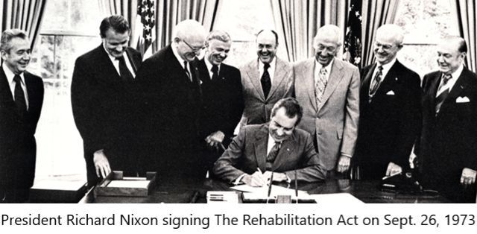

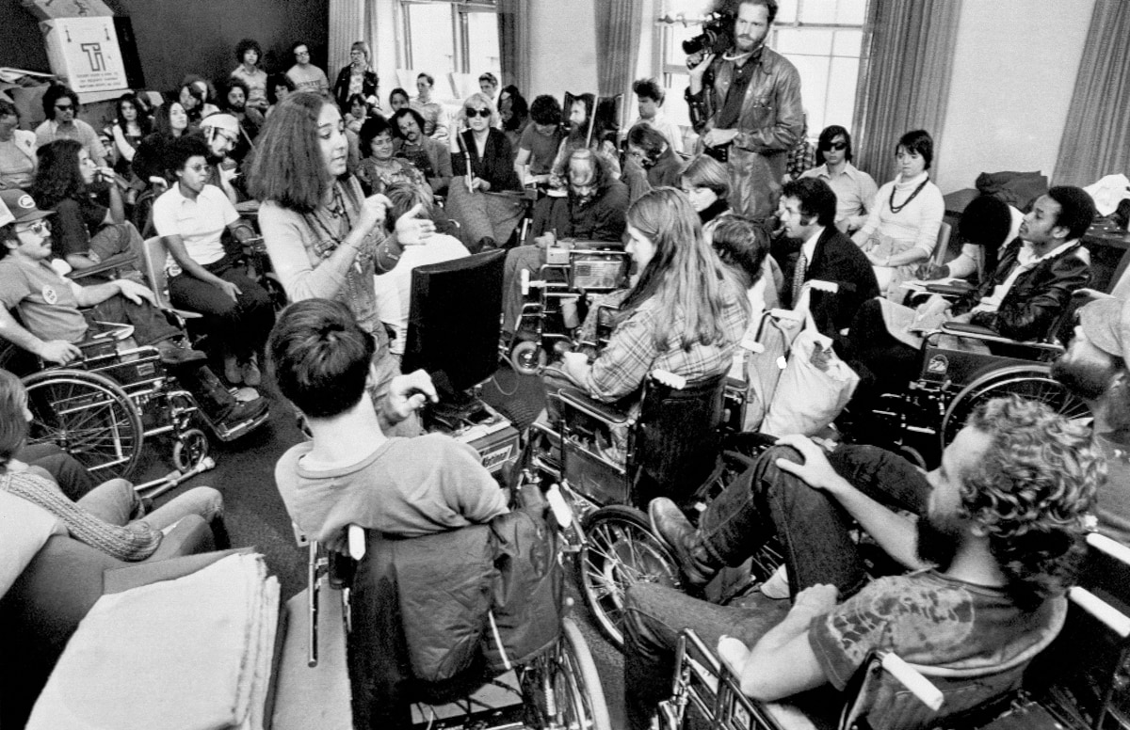
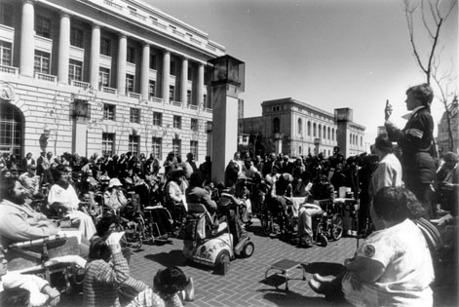
Section 504 is part of the
Rehabilitation Act of 1973
It was the first federal civil rights law protecting people with disabilities. Before the ADA had its glow up, 504 was already in the trenches.
The core rule is simple:
If an organization takes federal financial assistance, it cannot discriminate against a qualified person with a disability.
That’s it. Elegant. Ruthless. Powerful.

🎯 Who Does It Apply To?
Section 504 covers any program or activity receiving federal funds. That includes:
• Public schools and universities
• Hospitals and healthcare providers
• State agencies
• Workforce development programs
• Vocational rehabilitation agencies
• Nonprofits receiving federal grants
• Private employers receiving federal contracts or assistance
If they touch federal money, 504 is in the room.

👤 Who Is Protected?
A person with a disability under Section 504 is someone who:
- Has a physical or mental impairment
- That substantially limits
- One or more major life activities
Major life activities include things like walking, seeing, working, learning, concentrating, breathing, communicating. Also major bodily functions. Congress went wide on purpose.
And you do not have to be totally unable to do something. “Substantially limits” does not mean “completely prevents.”

⚖️ What Does It Require?
Section 504 requires:

1. Nondiscrimination
No exclusion. No denial of benefits. No unequal treatment.

2. Reasonable Accommodations
If a qualified person with a disability needs adjustments to access a program, the entity must provide them unless it causes undue hardship or fundamentally alters the program.

3. Equal Opportunity
Not charity. Not sympathy. Equal shot.

4. Accessible Facilities
New construction must be accessible. Existing buildings must be program-accessible.

🏫 Section 504 in SchoolsSection 504 is part of the
Rehabilitation Act of 1973

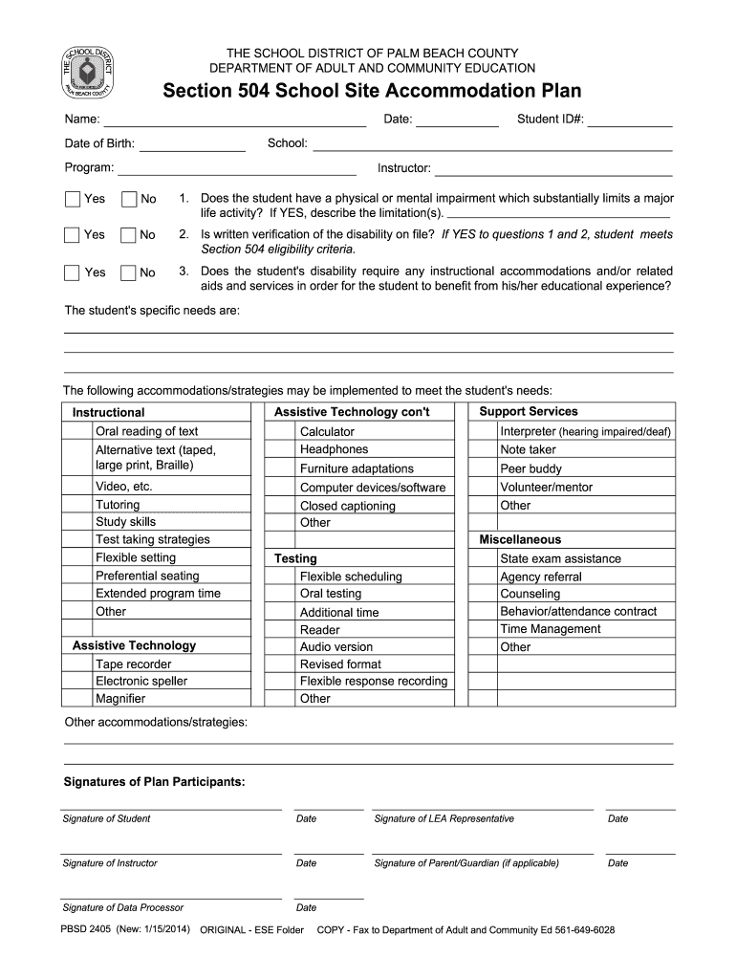

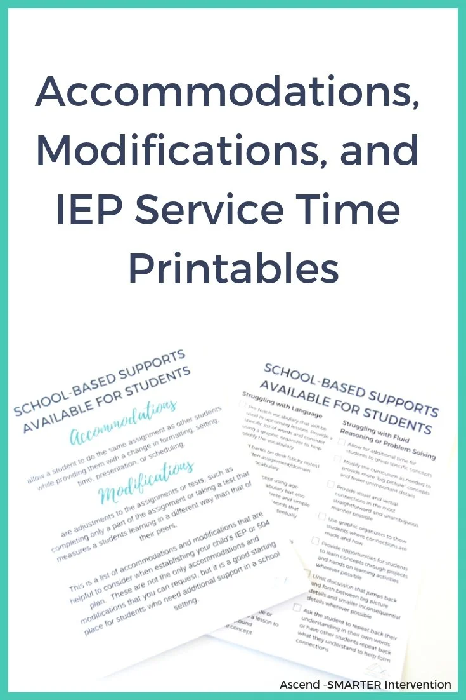
In K–12 education, Section 504 is why students can get a 504 Plan.
That plan can include:
• Extended test time
• Modified assignments
• Accessible seating
• Behavioral supports
• Health-related accommodations
Unlike IDEA, 504 does not require specialized instruction. It ensures access.

🏛 Section 504 vs. the ADA
Americans with Disabilities Act of 1990 came later and expanded protections.
Here’s the cheat sheet:
Section 504 | ADA
Applies to federally funded entities | Applies broadly to public and private sectors
Passed in 1973 | Passed in 1990
Foundation of modern disability law | Expanded and clarified protections
Think of 504 as the blueprint. ADA built the skyscraper.

🧠 Why It Still Matters
Section 504 is the legal backbone for:
• Vocational Rehabilitation services
• Equal access in higher education
• Healthcare nondiscrimination
• Workforce development programs
And here’s the part people miss:
You cannot deny someone participation in a federally funded program based on disability bias dressed up as policy.
If a program’s purpose is employment and independence for people with disabilities, it does not get to arbitrarily redraw the map because your goal makes them uncomfortable.
That’s not how civil rights works.

🛠 Enforcement
Complaints can be filed with:
• The relevant federal funding agency
• The Office for Civil Rights within the
U.S. Department of Education
• Or through federal court
Section 504 has teeth. Quiet teeth. But teeth.

🧩 Bottom Line
Section 504 says:
If you take federal money, you do not get to exclude people with disabilities.
You do not get to deny equal access.
You do not get to shrug and say “that’s just policy.”
It is not optional compliance. It is a civil rights obligation.
And it laid the groundwork for everything that followed.

